Thank you so much for spending some time with me here today. My name is Beto Paredes, and I am the President of Vivacity and very excited to share with you the information that we have in today’s presentation. I have got a really good message to share with you, one that I think that you are really going to love and hopefully will get you to come in and start working with us possibly as a promoter or even a customer of Vivacity.

I like to start off with just a few important questions:

* Are you currently worried about creating Job security?
* Looking for a way to build a real business that you can count on now and for the future?
* Wanting to control how you spend your time personally and professionally?

The answer to these questions, for many people, has been starting their own business with a company such as Vivacity, which is the best choice you can make. And, that’s what we’re going to talk about today….how Vivacity can be the answer to those questions.

Let's talk about what we like to call “THE PROBLEM”.

THE PROBLEM is that most of us are currently trading TIME of MONEY.

What does that mean??

If you have a job….even if it’s a job you love…..you go into an office and you are on someone else’s payroll and your time is not your own. Even if it’s on a salary basis, even if you have the choice of working lots of overtime, you really are coming in and being paid for the time you spend at that job. You’re working day after day, week after week, year after year. And, no matter how hard you work and how many hours you put in, your dream board is full of things that are just out of reach, just out of sight of what you believed you would be able to accomplish with the income that you currently have. The solution? ENTREPRENEURSHIP.

And OUR SOLUTION here is to build a PIPELINE with our products, systems and tools.

So, what does that mean?

We teach you how to

* Build a pipeline of customers; and
* Leverage the effort of others

We will work with you until you master these two skills and, when you do, you will be on your way to a tremendous income potential.

How do you do that with our system?

Well, we have already developed all of the tools that you need. Our Corporate Team has been in this business for a very long time. We know exactly what you need to become successful as a Promoter with our company. And we have great programs to get you started.

So say this to yourself: “*I can take control of my life and I can earn the income that I deserve.*”

You really do have to make that decision. No matter what kind of entrepreneur or business that you get into you have to really believe that you can actually get from where you are to somewhere better. And that is a personal development perspective. We care a tremendous amount about helping the individuals that join Vivacity get into the personal development mindset. We want to invite you very specifically to get into that mindset now as we go through the rest of our presentation.

Let’s talk a little bit about where the advantages are as a promoter like how is that we would be able to actually offer things that are useful to other people.

What are the products that we have? and what are they all about?

Vivacity reps have an opportunity to make tremendous change.

Let’s talk about SLEEP specifically. We have a product that is absolutely incredible for sleep. One of the highest, probably the highest claimed product that we have so far, as far as the testimonials are concerned.

SLEEP IN THE UNITED STATES

According to the national institute of neurological disorders and stroke, about 40 million people of the United States suffer from chronic long-term sleep disorders each year and an additional 20 million people experience occasional sleep problems.

Let’s just break it down to your demographic. So you join us become a promoter, now you have got incredible product to share with people, you can probably easily think of someone currently suffers from bad sleep. May be you are that person. One of the things that you really want to know with our company that we have broken all of our products down to simple lifestyle perspective. Not enough sleep, too fatigued during the day, that’s another problem. That has to do with our core perspective. Most people have one or the other of those going on. You are not getting enough sleep or they are fatigued during the day. We have a base model that is built around fixing that main issue with people. We will go into more about our products in just a little bit. But in sleep just by itself there is 40 million people just in United States, just nearly 60 million people that are definitely approachable to whatever degree to have this discussion about a product that we have.

Let’s talk about the other things that are going on here

Stimulant Sales: Sales of prescription stimulants have more than quintupled since 2002. If you want to add the kind of stimulants that have to do with store purchases like energy drinks. How popular are those? There is nothing wrong with wanting to have a drink that’s gonna boost your ability to perform especially if you are in sports. We have an incredible sports drink called Ignite. You should just replace all other copy and all other sports drink because this is just better for you. We really call it the smart drink. We definitely believe that. But just think about all the additional stimulants like your Red Bulls or anything with tar in it which is absolutely terrible for you. Couple that with all of the stimulant sells that are happening at the prescription level and you can see that there is a tremendous problem in our country with fatigue. You are definitely gonna be able to write down a couple of people who probably suffered from that. We have an amazing product that gives daily sustainable energy and is probably one of the most incredible products I take in on a daily basis and it's called Awaiken.

Again moving on. Each day, 46 people die from an overdose of prescription painkillers* in the United States.

Healthcare providers wrote 259 million prescription for painkillers in 2012, enough for every American adult to have a bottle of pills. Think about that number. That’s astronomical. Through diet, proper water intake, and intelligent supplementation like with our product called Mobility especially, you can combat a tremendous amount of pain that you feel in your body. Pain is very related to inflammation for most purposes. Especially as individuals get older really just joints and other parts of your body start to get a little bit more warm. You need good supplementation to keep supple in those areas. To keep vital which is actually part of our vitality pack. Which is one of the reasons why it is part and parcel to that formula.

So the reality is what can you do lifestyle wise to get out of the pain that you are in so that you can reduce the dependency that you have on prescription painkillers. Because they are terrible for you. They eat your stomach lining. There is even a big abrogacy in the medical industry right now to stop prescribing so many of them. But it is very very difficult when you look at the addiction level.

10 of the highest prescribing states for painkillers are in the South. Let’s talk about how significant that is. One of our main locations is in Florence, Alabama so this is close to our heart here. If you look at the states we will just use the dark purple as an example. It says number of painkiller prescriptions per 100 people.

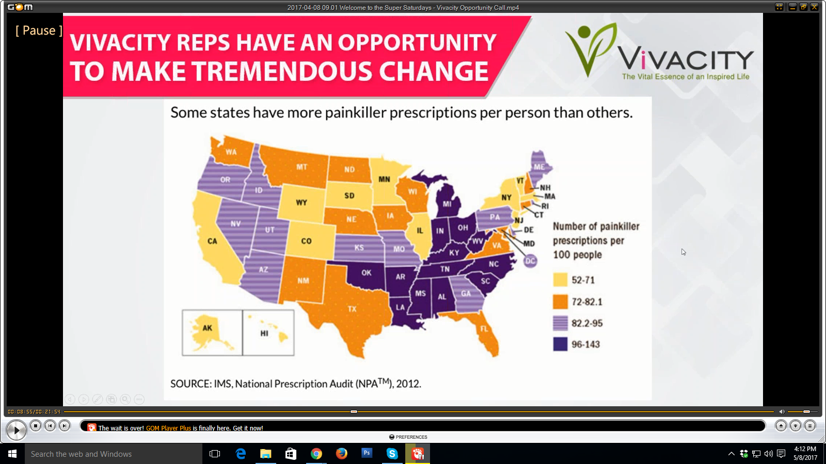

How do you even get to a number of 96-143 out of a 100 people? That’s because many people are actually on more than one painkiller prescription. May be even 3 or more. That’s how bad has gotten for people who are trying to manage their pain instead of looking at ways that may be they can improve their supplementation and lifestyle to get out of pain. Well if there are this many prescription painkillers out there, I am sure many of you know plenty of people that are very reliant on their prescriptions. And I am sure may be some of you are even feel that yourselves. I am not saying that we can replace, depending on what it is that ails you, but most certainly you owe it to yourself to learn whether or not making lifestyle adjustments and supplement chasing adjustments might help a tremendous amount of it. We believe it does, we have proven that it does. We have got testimonies that prove that our products work in this area. And here is another opportunity as a new promoter for you to approach people that you know about the products that you have. So far you have probably seen that that covers everyone. They are either in pain or they are not getting a very good sleep or they are feeling fatigued during the day, easy introductions to our lifestyle products makes this company a really fun company to be working with.

Look at the Overdose deaths involving Opioids, in the United States within 2000-2015

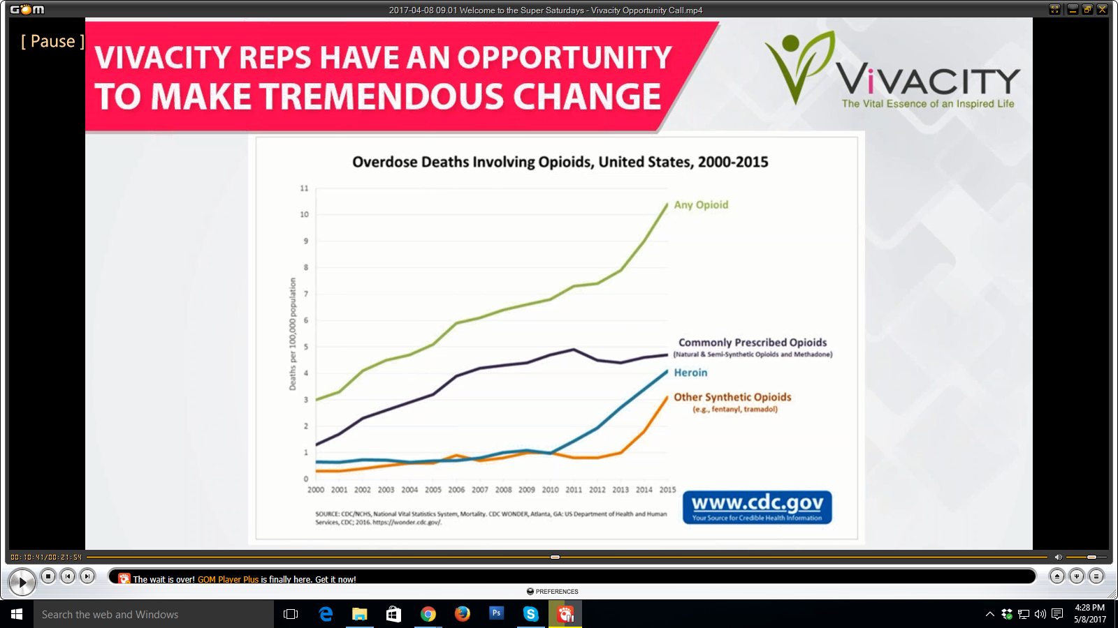

There is just so much going on and with the increase of use of painkiller prescription Opioids and even the focused stimulants that people are taking that there is an endless number of possibilities as a promoter of our company for you to introduce opportunities to get away from those things.

So how does that work exactly?

Well it works though our incredible products. So here is our product line right here.

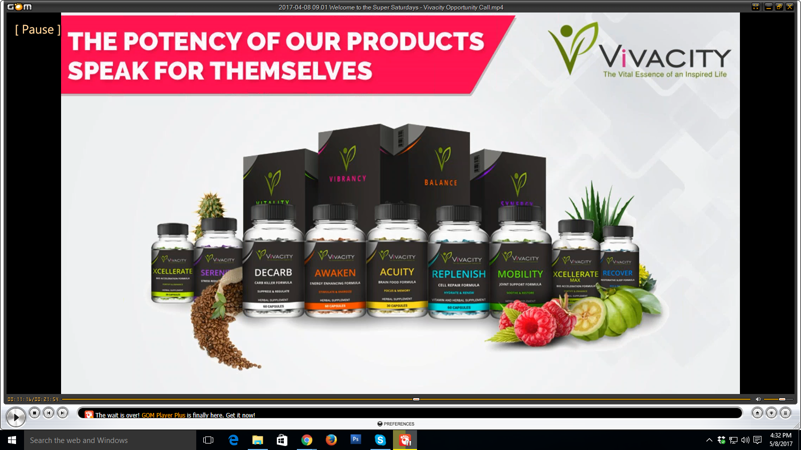

You can see the products there up front and then in the back we have our four programs. We keep it very simple here because most of the time everyone somehow sits into the major four categories that we have. For what may be ailing their life. And we very thoughtfully and very intelligently put this together. The CEO of the company Jerry James he has been in the medical device industry upto this point as a professional for over 30 years before he started this company. Part of his passion is helping relieve so much of the pain and suffering that he saw in that business by bringing the kinds of products that corrects the aspects of lifestyle that create tremendous dependency otherwise. We have a mission here. And that is to help people experience the shift. That is the shift in their health, the shift in their mindset. We will continue talking a little bit about that. I do want to point out the quality of our product.

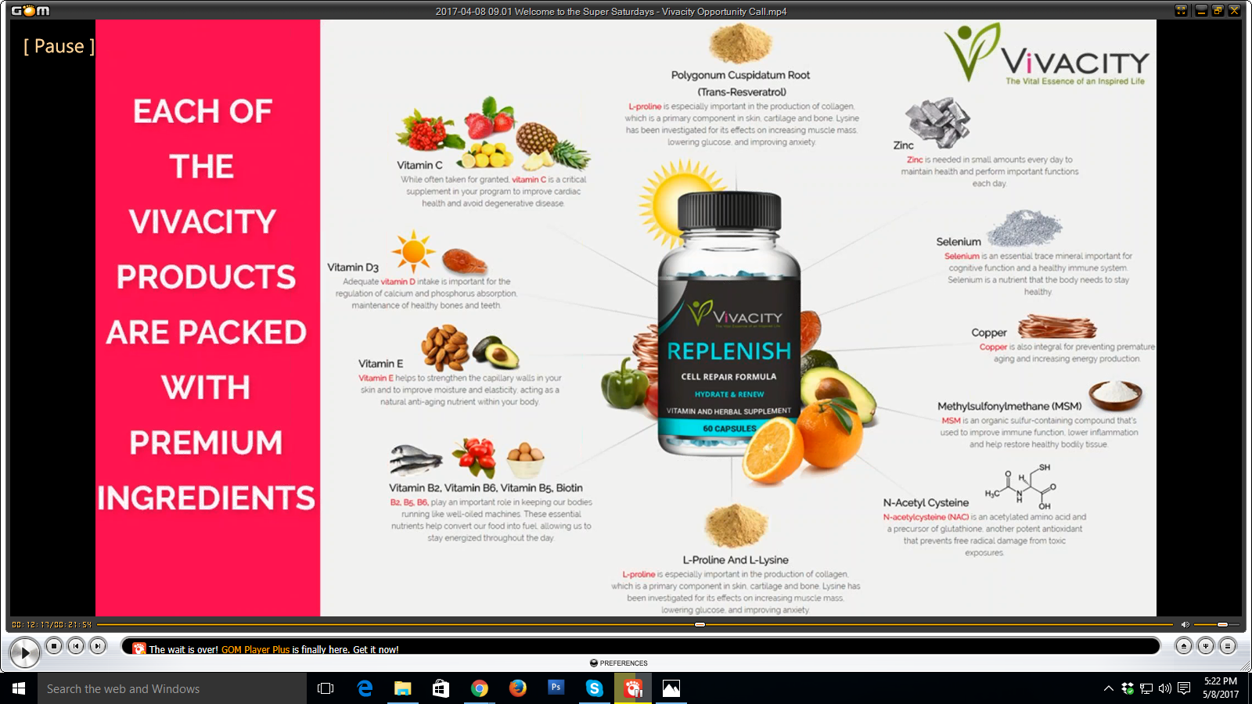

This is one of our products called Replenish. It is for incredible cellular regeneration. We actually sell this product as a beauty product as well because it does make your skin beautiful. But it really is a product that goes all the way into the very core of your cells and gives you that fountain of youth that really allows your cells to start doing more and being a lot help your resilience. So a lovely product but look at the tremendous amount of ingredients that we have in order to get that proper formula. Not only do we have incredible ingredients for each of the products that we have but we always buy the highest quality usually the most expensive, depending on where we get it, products in order to put into the actual formulas that we have. Lots of people don’t understand the difference between a premium products from a brand like ourselves and something you can pick up off the shelf. It can have the same ingredients and even the same amounts but the quality of ingredients are are completely and totally different. Our ingredient quality is so high that there is a standard and a rule set by Jerry, the CEO himself that we will never compromise that quality for cost ever. So you can guarantee that these products are potent. I take them everyday and if you haven’t tried some and if you are not ready to jump in as a promoter, buy some product, may be even get into the promoter pack. Go back to the individual that started with you here and go to pre enrollment and ether the Balance pack or one of the other three and decide once you take the product if you want to finish actually getting signed up. Because I’ll tell you the minute you take these products you are gonna want to be part of our company.

So how do we keep it simple?

The 24 hour core dynamic system, which is our base system. We have a system that encompasses the programs that we sell. The 24 hour core dynamic system consists of 4 major programs. Balance, Vitality, Synergy and Vibrancy.

Balance, it consists of the base of all 4 programs. And has to do with day and night. That is why it’s 24 hours. Which is Awaken I spoke about earlier, that daily sustainable energy and recover which really helps you get an incredible night’s sleep.

Vitality, it's built for those who suffer from blood sugar or chronic pain.

Synergy, is built for those that have high stress jobs or need something to really help them emotionally. It has two products that are absolutely amazing. Aquity, which is our brain food product and Sarinity, which helps you have that sustainable chemical feel in your body where you can get some good calm sustainable perspective. I take it every single day and that is the actual formula that I chose to be on. The supplementation that I put myself on through Vivacity has made incredible change in my life.

Vibrancy, has our sports drink or our smart drink Ignite and Replenish, one that I showed you before. Those are for very high activity individuals and those that put their body through a lot of stress. So if you are athletic and you put your body through a lot on a daily basis Replenish is better than any amount of Creatine that you can ever get your hands on for cellular recovery and when you are tearing and building muscles that’s super important. Now in general Replenish is an incredible product to anything that you have as well as our other products Xcellerate and Xcellerate Max.

One other thing that we do here little different than some companies is that we are big advocates of cannabinoids. And we have a cannabinoid whole food supplement that is incredibly good for you. Xcellerate and Xcellerate Max, these two products do exactly what they say they do. They will accelerate the other products that you are taking but not just the products from us, they will accelerate any level of nutrition. So you will get more out of the food that you eat, the oxygen that you breathe. They literally allow your cellular infrastructure to be able to function at a more absorbed level. So instead of losing it through the waste in your body you are absorbing a lot more of the nutrients in your body. It’s an incredible product to either purchase alone or you can add to any of the actual programs that we have.

Besides finding it very important to focus on body health we believe that mental health and being able to really make progress in your life. And do well as an individual especially as an entrepreneur here with us is of high importance. With that in mind we also find things that are related to energy medicine, acupuncture and a lot of what you would consider alternative therapy to be highly important to have as an additive to your health care as well.

Vio-Shift is a program that we have as a lifestyle method. It concentrates on:

* Meditation for concentration and health.
* High performance psychology and mindset.
* Energy healing.
* Wellness created through awareness.
* Diet information and food preparation.
* Nutritional information and education.

So not only do we give our promoters and our customers opportunity to take incredible products but we also help them with the total lifestyle perspective that you really need to have an incredible life.

Is Vivacity your answer to an extraordinary income?

I would say that it’s important for a company such as ours being a network marketing company to make sure that the answer is always yes. But let’s run through this.

* Can you start immediately? **YES**
* Is this plan aggressive and competitive? **YES**
* Can you work this part time? **YES**
* Can you work this full time? **Aboslutely**
* Can you replace your current income? **You can**
* Can you turn this into a $10,000 business? **You can.** Infact it’s a great goal to have.

THE TRUTH IS YOUR EARNING POTENTIAL IS TRULY UNLIMITED.

Our PAY PLAN is important to understand:

The Vivacity Max Velocity Pay Plan Rewards are Generous.

We Pay Our Promoters Weekly.

* We have vanishing autoship with three customer autoship subscriptions a month.
* A full full 20% retail commissions with daily bonus opportunities to 30%
* Fast start unlimited bonus opportunities to encourage team work.
* Matching bonuses on fast start and group volume commissions
* Powerful and easy to understand uni-level pay model
* Group volume commission percentages 7 levels deep with unlimited width
* Bonus pool earning opportunities with unlimited depth
* And achievable rank advancements with increased earning potential.

So we have a pay plan that is as good, if not better than the top five percent in the entire industry. We like to pay as much as possible out to the individuals that are making the effort and bing our partners as promoters in the company.

OUR PROMOTER OPPORTUNITIES ARE GOING TO CHANGE THE INDUSTRY

Social media marketing tools and programs that we have developed in-house are things that you are not going to find anywhere else.

We have extensive promoter training held every single week covering a myriad subjects in entrepreneurship, business ownership, and Vivacity marketing methodologies. There are fully featured back office will all the marketing tools that you would expect to see in a thriving network marketing company.

Super Saturdays, which is beginning here with this opportunity call are an incredible opportunity to come and learn a lot more about being a professional getting the right mindset, product knowledge. Saturdays are very good to spend with us. In our super saturdays we teach about

* Business Mastery
* Social Media Marketing
* Opportunity Sharing
* Leadership Development
* Prospecting Techniques
* Presentation Skills
* Finding Customers
* Networking Expertise
* Team Management

So this is you:

* Making a decision to change your future life story
* Building a testimonial you can share with others
* Selling in person and online as a professional distributor
* Building the lifestyle you want on your own terms
* Sharing with people and building an organization
* Building a part of an amazing team of achievers.

This is you:

* Spreading an amazing story of health through life changing products and programs
* Helping others change their overall wellness, vitality and hope for the future
* Improving your social skills, marketing savvy, creativity, and capacity to make more money
* Changing your own life view on purpose and learning the power of teamwork

So LET’S GET STARTED TODAY!

The sooner you begin the faster you can start earning an incredible income and live the lifestyle you deserve.

Get back with the person that brought you here and find out how you can join us as a Vivacity promoter and start your next journey to making an incredible income.

Thank you so much for spending some time with me here today. My name is Beto Paredes, and I am the President of Vivacity and very excited to share with you the information that we have in today’s presentation. I have got a really good message to share with you, one that I think that you are really going to love and hopefully will get you to come in and start working with us possibly as a promoter or even a customer of Vivacity.

I like to start off with just a few important questions:

* Are you currently worried about creating Job security?
* Looking for a way to build a real business that you can count on now and for the future?
* Wanting to control how you spend your time personally and professionally?

The answer to these questions, for many people, has been starting their own business with a company such as Vivacity, which is the best choice you can make. And, that’s what we’re going to talk about today….how Vivacity can be the answer to those questions.

Let's talk about what we like to call “THE PROBLEM”.

THE PROBLEM is that most of us are currently trading TIME of MONEY.

What does that mean??

If you have a job….even if it’s a job you love…..you go into an office and you are on someone else’s payroll and your time is not your own. Even if it’s on a salary basis, even if you have the choice of working lots of overtime, you really are coming in and being paid for the time you spend at that job. You’re working day after day, week after week, year after year. And, no matter how hard you work and how many hours you put in, your dream board is full of things that are just out of reach, just out of sight of what you believed you would be able to accomplish with the income that you currently have. The solution? ENTREPRENEURSHIP.

And OUR SOLUTION here is to build a PIPELINE with our products, systems and tools.

So, what does that mean?

We teach you how to

* Build a pipeline of customers; and
* Leverage the effort of others

We will work with you until you master these two skills and, when you do, you will be on your way to a tremendous income potential.

How do you do that with our system?

Well, we have already developed all of the tools that you need. Our Corporate Team has been in this business for a very long time. We know exactly what you need to become successful as a Promoter with our company. And we have great programs to get you started.

So say this to yourself: “*I can take control of my life and I can earn the income that I deserve.*”

You really do have to make that decision. No matter what kind of entrepreneur or business that you get into you have to really believe that you can actually get from where you are to somewhere better. And that is a personal development perspective. We care a tremendous amount about helping the individuals that join Vivacity get into the personal development mindset. We want to invite you very specifically to get into that mindset now as we go through the rest of our presentation.

Let’s talk a little bit about where the advantages are as a promoter like how is that we would be able to actually offer things that are useful to other people.

What are the products that we have? and what are they all about?

Vivacity reps have an opportunity to make tremendous change.

Let’s talk about SLEEP specifically. We have a product that is absolutely incredible for sleep. One of the highest, probably the highest claimed product that we have so far, as far as the testimonials are concerned.

SLEEP IN THE UNITED STATES

According to the national institute of neurological disorders and stroke, about 40 million people of the United States suffer from chronic long-term sleep disorders each year and an additional 20 million people experience occasional sleep problems.

Let’s just break it down to your demographic. So you join us become a promoter, now you have got incredible product to share with people, you can probably easily think of someone currently suffers from bad sleep. May be you are that person. One of the things that you really want to know with our company that we have broken all of our products down to simple lifestyle perspective. Not enough sleep, too fatigued during the day, that’s another problem. That has to do with our core perspective. Most people have one or the other of those going on. You are not getting enough sleep or they are fatigued during the day. We have a base model that is built around fixing that main issue with people. We will go into more about our products in just a little bit. But in sleep just by itself there is 40 million people just in United States, just nearly 60 million people that are definitely approachable to whatever degree to have this discussion about a product that we have.

Let’s talk about the other things that are going on here

Stimulant Sales: Sales of prescription stimulants have more than quintupled since 2002. If you want to add the kind of stimulants that have to do with store purchases like energy drinks. How popular are those? There is nothing wrong with wanting to have a drink that’s gonna boost your ability to perform especially if you are in sports. We have an incredible sports drink called Ignite. You should just replace all other copy and all other sports drink because this is just better for you. We really call it the smart drink. We definitely believe that. But just think about all the additional stimulants like your Red Bulls or anything with tar in it which is absolutely terrible for you. Couple that with all of the stimulant sells that are happening at the prescription level and you can see that there is a tremendous problem in our country with fatigue. You are definitely gonna be able to write down a couple of people who probably suffered from that. We have an amazing product that gives daily sustainable energy and is probably one of the most incredible products I take in on a daily basis and it's called Awaiken.

Again moving on. Each day, 46 people die from an overdose of prescription painkillers* in the United States.

Healthcare providers wrote 259 million prescription for painkillers in 2012, enough for every American adult to have a bottle of pills. Think about that number. That’s astronomical. Through diet, proper water intake, and intelligent supplementation like with our product called Mobility especially, you can combat a tremendous amount of pain that you feel in your body. Pain is very related to inflammation for most purposes. Especially as individuals get older really just joints and other parts of your body start to get a little bit more warm. You need good supplementation to keep supple in those areas. To keep vital which is actually part of our vitality pack. Which is one of the reasons why it is part and parcel to that formula.

So the reality is what can you do lifestyle wise to get out of the pain that you are in so that you can reduce the dependency that you have on prescription painkillers. Because they are terrible for you. They eat your stomach lining. There is even a big abrogacy in the medical industry right now to stop prescribing so many of them. But it is very very difficult when you look at the addiction level.

10 of the highest prescribing states for painkillers are in the South. Let’s talk about how significant that is. One of our main locations is in Florence, Alabama so this is close to our heart here. If you look at the states we will just use the dark purple as an example. It says number of painkiller prescriptions per 100 people.



How do you even get to a number of 96-143 out of a 100 people? That’s because many people are actually on more than one painkiller prescription. May be even 3 or more. That’s how bad has gotten for people who are trying to manage their pain instead of looking at ways that may be they can improve their supplementation and lifestyle to get out of pain. Well if there are this many prescription painkillers out there, I am sure many of you know plenty of people that are very reliant on their prescriptions. And I am sure may be some of you are even feel that yourselves. I am not saying that we can replace, depending on what it is that ails you, but most certainly you owe it to yourself to learn whether or not making lifestyle adjustments and supplement chasing adjustments might help a tremendous amount of it. We believe it does, we have proven that it does. We have got testimonies that prove that our products work in this area. And here is another opportunity as a new promoter for you to approach people that you know about the products that you have. So far you have probably seen that that covers everyone. They are either in pain or they are not getting a very good sleep or they are feeling fatigued during the day, easy introductions to our lifestyle products makes this company a really fun company to be working with.

Look at the Overdose deaths involving Opioids, in the United States within 2000-2015



There is just so much going on and with the increase of use of painkiller prescription Opioids and even the focused stimulants that people are taking that there is an endless number of possibilities as a promoter of our company for you to introduce opportunities to get away from those things.

So how does that work exactly?

Well it works though our incredible products. So here is our product line right here.



You can see the products there up front and then in the back we have our four programs. We keep it very simple here because most of the time everyone somehow sits into the major four categories that we have. For what may be ailing their life. And we very thoughtfully and very intelligently put this together. The CEO of the company Jerry James he has been in the medical device industry upto this point as a professional for over 30 years before he started this company. Part of his passion is helping relieve so much of the pain and suffering that he saw in that business by bringing the kinds of products that corrects the aspects of lifestyle that create tremendous dependency otherwise. We have a mission here. And that is to help people experience the shift. That is the shift in their health, the shift in their mindset. We will continue talking a little bit about that. I do want to point out the quality of our product.



This is one of our products called Replenish. It is for incredible cellular regeneration. We actually sell this product as a beauty product as well because it does make your skin beautiful. But it really is a product that goes all the way into the very core of your cells and gives you that fountain of youth that really allows your cells to start doing more and being a lot help your resilience. So a lovely product but look at the tremendous amount of ingredients that we have in order to get that proper formula. Not only do we have incredible ingredients for each of the products that we have but we always buy the highest quality usually the most expensive, depending on where we get it, products in order to put into the actual formulas that we have. Lots of people don’t understand the difference between a premium products from a brand like ourselves and something you can pick up off the shelf. It can have the same ingredients and even the same amounts but the quality of ingredients are are completely and totally different. Our ingredient quality is so high that there is a standard and a rule set by Jerry, the CEO himself that we will never compromise that quality for cost ever. So you can guarantee that these products are potent. I take them everyday and if you haven’t tried some and if you are not ready to jump in as a promoter, buy some product, may be even get into the promoter pack. Go back to the individual that started with you here and go to pre enrollment and ether the Balance pack or one of the other three and decide once you take the product if you want to finish actually getting signed up. Because I’ll tell you the minute you take these products you are gonna want to be part of our company.

So how do we keep it simple?

The 24 hour core dynamic system, which is our base system. We have a system that encompasses the programs that we sell. The 24 hour core dynamic system consists of 4 major programs. Balance, Vitality, Synergy and Vibrancy.

Balance, it consists of the base of all 4 programs. And has to do with day and night. That is why it’s 24 hours. Which is Awaken I spoke about earlier, that daily sustainable energy and recover which really helps you get an incredible night’s sleep.

Vitality, it's built for those who suffer from blood sugar or chronic pain.

Synergy, is built for those that have high stress jobs or need something to really help them emotionally. It has two products that are absolutely amazing. Aquity, which is our brain food product and Sarinity, which helps you have that sustainable chemical feel in your body where you can get some good calm sustainable perspective. I take it every single day and that is the actual formula that I chose to be on. The supplementation that I put myself on through Vivacity has made incredible change in my life.

Vibrancy, has our sports drink or our smart drink Ignite and Replenish, one that I showed you before. Those are for very high activity individuals and those that put their body through a lot of stress. So if you are athletic and you put your body through a lot on a daily basis Replenish is better than any amount of Creatine that you can ever get your hands on for cellular recovery and when you are tearing and building muscles that’s super important. Now in general Replenish is an incredible product to anything that you have as well as our other products Xcellerate and Xcellerate Max.

One other thing that we do here little different than some companies is that we are big advocates of cannabinoids. And we have a cannabinoid whole food supplement that is incredibly good for you. Xcellerate and Xcellerate Max, these two products do exactly what they say they do. They will accelerate the other products that you are taking but not just the products from us, they will accelerate any level of nutrition. So you will get more out of the food that you eat, the oxygen that you breathe. They literally allow your cellular infrastructure to be able to function at a more absorbed level. So instead of losing it through the waste in your body you are absorbing a lot more of the nutrients in your body. It’s an incredible product to either purchase alone or you can add to any of the actual programs that we have.

Besides finding it very important to focus on body health we believe that mental health and being able to really make progress in your life. And do well as an individual especially as an entrepreneur here with us is of high importance. With that in mind we also find things that are related to energy medicine, acupuncture and a lot of what you would consider alternative therapy to be highly important to have as an additive to your health care as well.

Vio-Shift is a program that we have as a lifestyle method. It concentrates on:

* Meditation for concentration and health.
* High performance psychology and mindset.
* Energy healing.
* Wellness created through awareness.
* Diet information and food preparation.
* Nutritional information and education.

So not only do we give our promoters and our customers opportunity to take incredible products but we also help them with the total lifestyle perspective that you really need to have an incredible life.

Is Vivacity your answer to an extraordinary income?

I would say that it’s important for a company such as ours being a network marketing company to make sure that the answer is always yes. But let’s run through this.

* Can you start immediately? **YES**
* Is this plan aggressive and competitive? **YES**
* Can you work this part time? **YES**
* Can you work this full time? **Aboslutely**
* Can you replace your current income? **You can**
* Can you turn this into a $10,000 business? **You can.** Infact it’s a great goal to have.

THE TRUTH IS YOUR EARNING POTENTIAL IS TRULY UNLIMITED.

Our PAY PLAN is important to understand:

The Vivacity Max Velocity Pay Plan Rewards are Generous.

We Pay Our Promoters Weekly.

* We have vanishing autoship with three customer autoship subscriptions a month.
* A full full 20% retail commissions with daily bonus opportunities to 30%
* Fast start unlimited bonus opportunities to encourage team work.
* Matching bonuses on fast start and group volume commissions
* Powerful and easy to understand uni-level pay model
* Group volume commission percentages 7 levels deep with unlimited width
* Bonus pool earning opportunities with unlimited depth
* And achievable rank advancements with increased earning potential.

So we have a pay plan that is as good, if not better than the top five percent in the entire industry. We like to pay as much as possible out to the individuals that are making the effort and bing our partners as promoters in the company.

OUR PROMOTER OPPORTUNITIES ARE GOING TO CHANGE THE INDUSTRY

Social media marketing tools and programs that we have developed in-house are things that you are not going to find anywhere else.

We have extensive promoter training held every single week covering a myriad subjects in entrepreneurship, business ownership, and Vivacity marketing methodologies. There are fully featured back office will all the marketing tools that you would expect to see in a thriving network marketing company.

Super Saturdays, which is beginning here with this opportunity call are an incredible opportunity to come and learn a lot more about being a professional getting the right mindset, product knowledge. Saturdays are very good to spend with us. In our super saturdays we teach about

* Business Mastery
* Social Media Marketing
* Opportunity Sharing
* Leadership Development
* Prospecting Techniques
* Presentation Skills
* Finding Customers
* Networking Expertise
* Team Management

So this is you:

* Making a decision to change your future life story
* Building a testimonial you can share with others
* Selling in person and online as a professional distributor
* Building the lifestyle you want on your own terms
* Sharing with people and building an organization
* Building a part of an amazing team of achievers.

This is you:

* Spreading an amazing story of health through life changing products and programs
* Helping others change their overall wellness, vitality and hope for the future
* Improving your social skills, marketing savvy, creativity, and capacity to make more money
* Changing your own life view on purpose and learning the power of teamwork

So LET’S GET STARTED TODAY!

The sooner you begin the faster you can start earning an incredible income and live the lifestyle you deserve.

Get back with the person that brought you here and find out how you can join us as a Vivacity promoter and start your next journey to making an incredible income.

Thank you so much for spending some time with me here today. My name is Beto Paredes, and I am the President of Vivacity and very excited to share with you the information that we have in today’s presentation. I have got a really good message to share with you, one that I think that you are really going to love and hopefully will get you to come in and start working with us possibly as a promoter or even a customer of Vivacity.

I like to start off with just a few important questions:

* Are you currently worried about creating Job security?
* Looking for a way to build a real business that you can count on now and for the future?
* Wanting to control how you spend your time personally and professionally?

The answer to these questions, for many people, has been starting their own business with a company such as Vivacity, which is the best choice you can make. And, that’s what we’re going to talk about today….how Vivacity can be the answer to those questions.

Let's talk about what we like to call “THE PROBLEM”.

THE PROBLEM is that most of us are currently trading TIME of MONEY.

What does that mean??

If you have a job….even if it’s a job you love…..you go into an office and you are on someone else’s payroll and your time is not your own. Even if it’s on a salary basis, even if you have the choice of working lots of overtime, you really are coming in and being paid for the time you spend at that job. You’re working day after day, week after week, year after year. And, no matter how hard you work and how many hours you put in, your dream board is full of things that are just out of reach, just out of sight of what you believed you would be able to accomplish with the income that you currently have. The solution? ENTREPRENEURSHIP.

And OUR SOLUTION here is to build a PIPELINE with our products, systems and tools.

So, what does that mean?

We teach you how to

* Build a pipeline of customers; and
* Leverage the effort of others

We will work with you until you master these two skills and, when you do, you will be on your way to a tremendous income potential.

How do you do that with our system?

Well, we have already developed all of the tools that you need. Our Corporate Team has been in this business for a very long time. We know exactly what you need to become successful as a Promoter with our company. And we have great programs to get you started.

So say this to yourself: “*I can take control of my life and I can earn the income that I deserve.*”

You really do have to make that decision. No matter what kind of entrepreneur or business that you get into you have to really believe that you can actually get from where you are to somewhere better. And that is a personal development perspective. We care a tremendous amount about helping the individuals that join Vivacity get into the personal development mindset. We want to invite you very specifically to get into that mindset now as we go through the rest of our presentation.

Let’s talk a little bit about where the advantages are as a promoter like how is that we would be able to actually offer things that are useful to other people.

What are the products that we have? and what are they all about?

Vivacity reps have an opportunity to make tremendous change.

Let’s talk about SLEEP specifically. We have a product that is absolutely incredible for sleep. One of the highest, probably the highest claimed product that we have so far, as far as the testimonials are concerned.

SLEEP IN THE UNITED STATES

According to the national institute of neurological disorders and stroke, about 40 million people of the United States suffer from chronic long-term sleep disorders each year and an additional 20 million people experience occasional sleep problems.

Let’s just break it down to your demographic. So you join us become a promoter, now you have got incredible product to share with people, you can probably easily think of someone currently suffers from bad sleep. May be you are that person. One of the things that you really want to know with our company that we have broken all of our products down to simple lifestyle perspective. Not enough sleep, too fatigued during the day, that’s another problem. That has to do with our core perspective. Most people have one or the other of those going on. You are not getting enough sleep or they are fatigued during the day. We have a base model that is built around fixing that main issue with people. We will go into more about our products in just a little bit. But in sleep just by itself there is 40 million people just in United States, just nearly 60 million people that are definitely approachable to whatever degree to have this discussion about a product that we have.

Let’s talk about the other things that are going on here

Stimulant Sales: Sales of prescription stimulants have more than quintupled since 2002. If you want to add the kind of stimulants that have to do with store purchases like energy drinks. How popular are those? There is nothing wrong with wanting to have a drink that’s gonna boost your ability to perform especially if you are in sports. We have an incredible sports drink called Ignite. You should just replace all other copy and all other sports drink because this is just better for you. We really call it the smart drink. We definitely believe that. But just think about all the additional stimulants like your Red Bulls or anything with tar in it which is absolutely terrible for you. Couple that with all of the stimulant sells that are happening at the prescription level and you can see that there is a tremendous problem in our country with fatigue. You are definitely gonna be able to write down a couple of people who probably suffered from that. We have an amazing product that gives daily sustainable energy and is probably one of the most incredible products I take in on a daily basis and it's called Awaiken.

Again moving on. Each day, 46 people die from an overdose of prescription painkillers* in the United States.

Healthcare providers wrote 259 million prescription for painkillers in 2012, enough for every American adult to have a bottle of pills. Think about that number. That’s astronomical. Through diet, proper water intake, and intelligent supplementation like with our product called Mobility especially, you can combat a tremendous amount of pain that you feel in your body. Pain is very related to inflammation for most purposes. Especially as individuals get older really just joints and other parts of your body start to get a little bit more warm. You need good supplementation to keep supple in those areas. To keep vital which is actually part of our vitality pack. Which is one of the reasons why it is part and parcel to that formula.

So the reality is what can you do lifestyle wise to get out of the pain that you are in so that you can reduce the dependency that you have on prescription painkillers. Because they are terrible for you. They eat your stomach lining. There is even a big abrogacy in the medical industry right now to stop prescribing so many of them. But it is very very difficult when you look at the addiction level.

10 of the highest prescribing states for painkillers are in the South. Let’s talk about how significant that is. One of our main locations is in Florence, Alabama so this is close to our heart here. If you look at the states we will just use the dark purple as an example. It says number of painkiller prescriptions per 100 people.



How do you even get to a number of 96-143 out of a 100 people? That’s because many people are actually on more than one painkiller prescription. May be even 3 or more. That’s how bad has gotten for people who are trying to manage their pain instead of looking at ways that may be they can improve their supplementation and lifestyle to get out of pain. Well if there are this many prescription painkillers out there, I am sure many of you know plenty of people that are very reliant on their prescriptions. And I am sure may be some of you are even feel that yourselves. I am not saying that we can replace, depending on what it is that ails you, but most certainly you owe it to yourself to learn whether or not making lifestyle adjustments and supplement chasing adjustments might help a tremendous amount of it. We believe it does, we have proven that it does. We have got testimonies that prove that our products work in this area. And here is another opportunity as a new promoter for you to approach people that you know about the products that you have. So far you have probably seen that that covers everyone. They are either in pain or they are not getting a very good sleep or they are feeling fatigued during the day, easy introductions to our lifestyle products makes this company a really fun company to be working with.

Look at the Overdose deaths involving Opioids, in the United States within 2000-2015



There is just so much going on and with the increase of use of painkiller prescription Opioids and even the focused stimulants that people are taking that there is an endless number of possibilities as a promoter of our company for you to introduce opportunities to get away from those things.

So how does that work exactly?

Well it works though our incredible products. So here is our product line right here.



You can see the products there up front and then in the back we have our four programs. We keep it very simple here because most of the time everyone somehow sits into the major four categories that we have. For what may be ailing their life. And we very thoughtfully and very intelligently put this together. The CEO of the company Jerry James he has been in the medical device industry upto this point as a professional for over 30 years before he started this company. Part of his passion is helping relieve so much of the pain and suffering that he saw in that business by bringing the kinds of products that corrects the aspects of lifestyle that create tremendous dependency otherwise. We have a mission here. And that is to help people experience the shift. That is the shift in their health, the shift in their mindset. We will continue talking a little bit about that. I do want to point out the quality of our product.



This is one of our products called Replenish. It is for incredible cellular regeneration. We actually sell this product as a beauty product as well because it does make your skin beautiful. But it really is a product that goes all the way into the very core of your cells and gives you that fountain of youth that really allows your cells to start doing more and being a lot help your resilience. So a lovely product but look at the tremendous amount of ingredients that we have in order to get that proper formula. Not only do we have incredible ingredients for each of the products that we have but we always buy the highest quality usually the most expensive, depending on where we get it, products in order to put into the actual formulas that we have. Lots of people don’t understand the difference between a premium products from a brand like ourselves and something you can pick up off the shelf. It can have the same ingredients and even the same amounts but the quality of ingredients are are completely and totally different. Our ingredient quality is so high that there is a standard and a rule set by Jerry, the CEO himself that we will never compromise that quality for cost ever. So you can guarantee that these products are potent. I take them everyday and if you haven’t tried some and if you are not ready to jump in as a promoter, buy some product, may be even get into the promoter pack. Go back to the individual that started with you here and go to pre enrollment and ether the Balance pack or one of the other three and decide once you take the product if you want to finish actually getting signed up. Because I’ll tell you the minute you take these products you are gonna want to be part of our company.

So how do we keep it simple?

The 24 hour core dynamic system, which is our base system. We have a system that encompasses the programs that we sell. The 24 hour core dynamic system consists of 4 major programs. Balance, Vitality, Synergy and Vibrancy.

Balance, it consists of the base of all 4 programs. And has to do with day and night. That is why it’s 24 hours. Which is Awaken I spoke about earlier, that daily sustainable energy and recover which really helps you get an incredible night’s sleep.

Vitality, it's built for those who suffer from blood sugar or chronic pain.

Synergy, is built for those that have high stress jobs or need something to really help them emotionally. It has two products that are absolutely amazing. Aquity, which is our brain food product and Sarinity, which helps you have that sustainable chemical feel in your body where you can get some good calm sustainable perspective. I take it every single day and that is the actual formula that I chose to be on. The supplementation that I put myself on through Vivacity has made incredible change in my life.

Vibrancy, has our sports drink or our smart drink Ignite and Replenish, one that I showed you before. Those are for very high activity individuals and those that put their body through a lot of stress. So if you are athletic and you put your body through a lot on a daily basis Replenish is better than any amount of Creatine that you can ever get your hands on for cellular recovery and when you are tearing and building muscles that’s super important. Now in general Replenish is an incredible product to anything that you have as well as our other products Xcellerate and Xcellerate Max.

One other thing that we do here little different than some companies is that we are big advocates of cannabinoids. And we have a cannabinoid whole food supplement that is incredibly good for you. Xcellerate and Xcellerate Max, these two products do exactly what they say they do. They will accelerate the other products that you are taking but not just the products from us, they will accelerate any level of nutrition. So you will get more out of the food that you eat, the oxygen that you breathe. They literally allow your cellular infrastructure to be able to function at a more absorbed level. So instead of losing it through the waste in your body you are absorbing a lot more of the nutrients in your body. It’s an incredible product to either purchase alone or you can add to any of the actual programs that we have.

Besides finding it very important to focus on body health we believe that mental health and being able to really make progress in your life. And do well as an individual especially as an entrepreneur here with us is of high importance. With that in mind we also find things that are related to energy medicine, acupuncture and a lot of what you would consider alternative therapy to be highly important to have as an additive to your health care as well.

Vio-Shift is a program that we have as a lifestyle method. It concentrates on:

* Meditation for concentration and health.
* High performance psychology and mindset.
* Energy healing.
* Wellness created through awareness.
* Diet information and food preparation.
* Nutritional information and education.

So not only do we give our promoters and our customers opportunity to take incredible products but we also help them with the total lifestyle perspective that you really need to have an incredible life.

Is Vivacity your answer to an extraordinary income?

I would say that it’s important for a company such as ours being a network marketing company to make sure that the answer is always yes. But let’s run through this.

* Can you start immediately? **YES**
* Is this plan aggressive and competitive? **YES**
* Can you work this part time? **YES**
* Can you work this full time? **Aboslutely**
* Can you replace your current income? **You can**
* Can you turn this into a $10,000 business? **You can.** Infact it’s a great goal to have.

THE TRUTH IS YOUR EARNING POTENTIAL IS TRULY UNLIMITED.

Our PAY PLAN is important to understand:

The Vivacity Max Velocity Pay Plan Rewards are Generous.

We Pay Our Promoters Weekly.

* We have vanishing autoship with three customer autoship subscriptions a month.
* A full full 20% retail commissions with daily bonus opportunities to 30%
* Fast start unlimited bonus opportunities to encourage team work.
* Matching bonuses on fast start and group volume commissions
* Powerful and easy to understand uni-level pay model
* Group volume commission percentages 7 levels deep with unlimited width
* Bonus pool earning opportunities with unlimited depth
* And achievable rank advancements with increased earning potential.

So we have a pay plan that is as good, if not better than the top five percent in the entire industry. We like to pay as much as possible out to the individuals that are making the effort and bing our partners as promoters in the company.

OUR PROMOTER OPPORTUNITIES ARE GOING TO CHANGE THE INDUSTRY

Social media marketing tools and programs that we have developed in-house are things that you are not going to find anywhere else.

We have extensive promoter training held every single week covering a myriad subjects in entrepreneurship, business ownership, and Vivacity marketing methodologies. There are fully featured back office will all the marketing tools that you would expect to see in a thriving network marketing company.

Super Saturdays, which is beginning here with this opportunity call are an incredible opportunity to come and learn a lot more about being a professional getting the right mindset, product knowledge. Saturdays are very good to spend with us. In our super saturdays we teach about

* Business Mastery
* Social Media Marketing
* Opportunity Sharing
* Leadership Development
* Prospecting Techniques
* Presentation Skills
* Finding Customers
* Networking Expertise
* Team Management

So this is you:

* Making a decision to change your future life story
* Building a testimonial you can share with others
* Selling in person and online as a professional distributor
* Building the lifestyle you want on your own terms
* Sharing with people and building an organization
* Building a part of an amazing team of achievers.

This is you:

* Spreading an amazing story of health through life changing products and programs
* Helping others change their overall wellness, vitality and hope for the future
* Improving your social skills, marketing savvy, creativity, and capacity to make more money
* Changing your own life view on purpose and learning the power of teamwork

So LET’S GET STARTED TODAY!

The sooner you begin the faster you can start earning an incredible income and live the lifestyle you deserve.

Get back with the person that brought you here and find out how you can join us as a Vivacity promoter and start your next journey to making an incredible income.